MRF User Manual

The MRF module allows you to enter in a problem online in the ERP system.
Each MRF will then be sent to the relevant person who will attend to your problem.
You will be able to monitor the status of your problem and also know who is attending to your problem.

Login into the ERP system  Choose the “MRF Menu”  Choose “Transaction Menu”  Choose “MRF – User” | 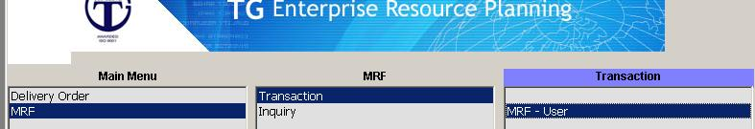
This is a sample of the screen for you to enter in your problem. | 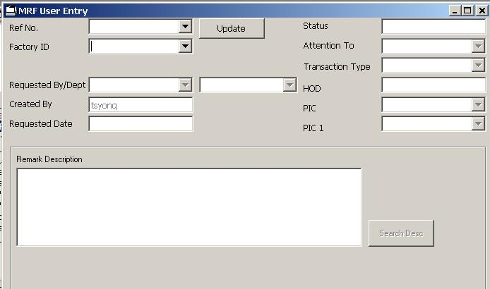
The frist step is to choose the factory you are in using the pull down menu. | 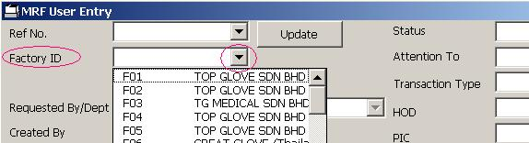
Once you have choosen the factory, the system will automatically generate an MRF number for you.  Keep this number as it is your reference runmber for you to keep track of the status of your problem.  It will also show who created this MRF. | 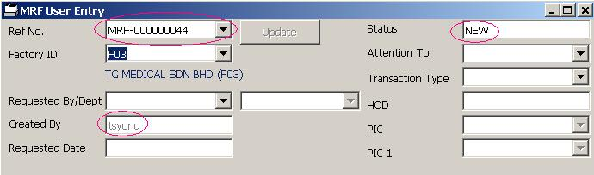

Choose who requested this MRF using the pull down menu.  If could be you or you are doing this MRF on behalf of someone. | 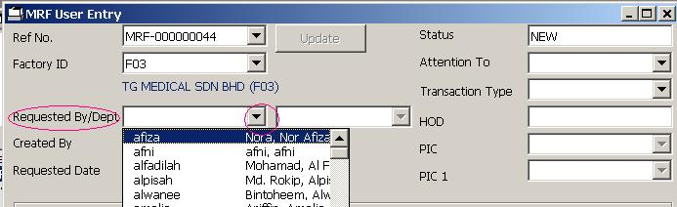
Next pick who this MRF should be attentioned to using the pull down menu.  In this example it is a printer problem so pick the IT dept | 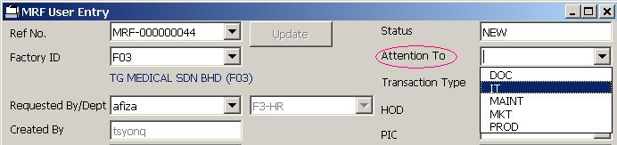
Next pick what type of specific transaction type for better response time.  In this example it is a hardware problem so pick the H/W team. | 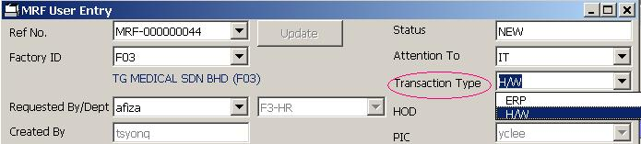
Now enter in a short description of your problem. Try to make it short but with as much information as possible. | 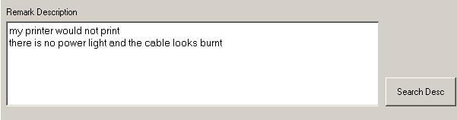
Finally sent the MRF by clicking on the send button.  Should you decide not to send this MRF then just click on the cancel button to cancel the MRF. | 